What will we be learning?  - Anatomy and Physiology | Why this? Why now?  This unit is a compulsory for the A level course which will be examined through the H555/01 paper at the end of year 13. | Key Words:  Skeleton  Muscle  Bone  Ligament  Tendon  Action potential  Lungs  Ventilation  Heart  Blood vessels  Aerobic  Anaerobic  Lactic acid  ATP-PC  Glucose  Glycolysis  Electron transport chain  Beta Oxidation  Acclimatisation
What will we learn?
  - Skeletal and muscular systems

  - Cardiovascular systems

  - Respiratory Systems

7.1 Energy for Exercise

7.2 Environmental effects on the Body

What opportunities are there for wider study?
Optional Booster sessions
Careers/degree courses
- Sports science
- Physiotherapy
- PE teacher
- Sports analysis
How will I be assessed?
- Everlearner set assignments/check points
- Topic tests
- End of unit tests
- Mock Exams
A LEVEL PE
ANATOMY & PHYSIOLOGY

What will we learn?  1.1 Skeletal and muscular systems  - The Bones and joints of the skeleton  - The roles of muscles  - Movement analysis  - Motor unit and muscle fibre type | 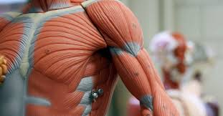
- Cardiovascular systems  - Structure of the heart  - Cardiac conduction system  - H.R, SV, Q  - Cardiac response to exercise  - HR Regulation  - Blood vessels  - Venus return  - Redistribution of Q  - Vascular Shunt | 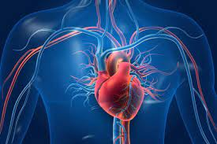
- Respiratory Systems  - Structure of the airways and lungs  - Gas transport  - Minute ventilation  - Lung volumes  - Mechanics of breathing  - Respiratory regulation  - Gaseous exchange  - Bohr Shift | 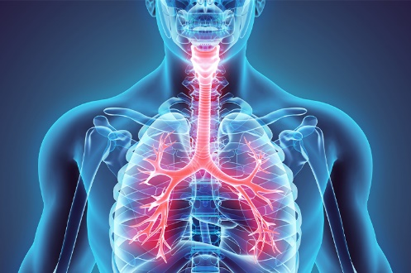
7.1 Energy for Exercise  - ATP PC  - Glycolytic system  - Aerobic system  - Krebs Cycle  - ETC  - Free Fatty Acids  - ATP Resynthesis  - Recovery times  - EPOC  - Alactacid  - Lactacid  - Implications of recovery on training | 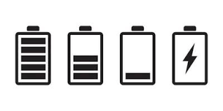
7.2 Environmental effects on the Body
- Effects of Altitude on CV and respiratory system
- Acclimatisation
- Exercise in the heat
- Effect on performance

